2/27/21

1)Text Message – Isaiah 42:1 NIV “Here is my servant, whom I uphold,
my chosen one in whom I delight; I will put my Spirit on him, and he will bring justice to the nations.

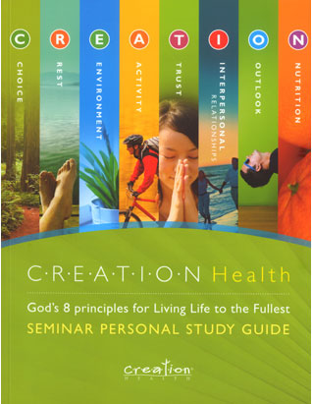

2) Creation Health Seminar coming March 3rd, 2021 at 7pm. Will be taught on Wed night during prayer meeting Livestream, join for health and wellness, please tell family and friends, we have plenty of books, come to church to pick them up. Will complete the Choice presentation. We had some significant technical difficulties with sound, those have been addressed and we hope you will join us again this Wed night.

3) Tithe and Offering can be returned online at ethantemplesda.org or at the church, also remember your Conference Wide Development Contribution, $100 per person to help smaller churches with their physical plants and evangelism. If you would like someone to come by and pick up you tithe and offering please contact any elder or deacon.

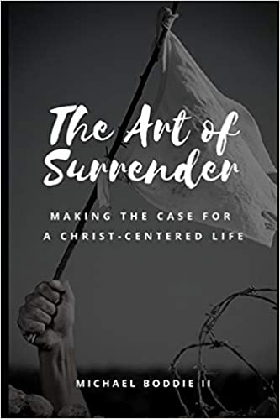
4) Pastor Michael Bodie Jr. has published The Art of Surrender, an evangelistic book on advocating a Christ-centered life, available on amazon.com. Please support our young minister.

5)Sabbath School Lower Division – Need actors for Bible Nugget series, see Tonya Gaymon or Elder R. Dulan, get in on the action

Adult Sabbath School – join us online at 10am by livestream

Young Adult Sabbath School age 15-18 – 10:30-11am by Facetime, please contact Alexis Dulan or Baylee Clark to be added to the group, Cornerstone Connections

6) Ethan Temple Prayer Line
Sunday- Friday 5:00 am and 7:00 pm
Sabbath 9:00 am and 7:00 pm
937-972-0230 Conference Code 280-8381
Replay-1-215-644-7700, enter Conference Code then enter number of recording
Join us every Wednesday, our Prayer & Fasting Day, from 5:00 am to 5:00 pm.

7) Worship Service – Enjoy by Livestream at https://livestream.com/ethantemplechurch also available on the prayer line by audio for those who do not have livestream capability. Please call in at 11am.

8 ) Community Service/Evangelism

a) Feeding the Homeless
Sister Ashley Banks is coordinating the feeding the homeless outreach every 5th Sunday of the month. If interested in joining this ministry, please contact Ashley.

9) Pastor Joseph Office Hours – Tuesday 10am-12pm, Thursday 6-8 pm. Please call Sis. Robin Davis, (937) 268-9851, to schedule at least 1 hour prior to desired appt time. Visits will be by zoom or telephone.

10) Please remember to reach out to our seniors and sick and shut in and pray for our bereaved families.

11) Prayer Meeting – Join us at 7pm on www.ethantemplesda.org, click on livestream or listen in on the prayer line, watch, listen and participate.

12) Community Resource Corner
Need a Listening Ear?
Free Counseling Services
Good Neighbor House Counseling Center
937-224-3003 Ext. 106.
Appointments are now available.
_________________________

Black History Spotlight
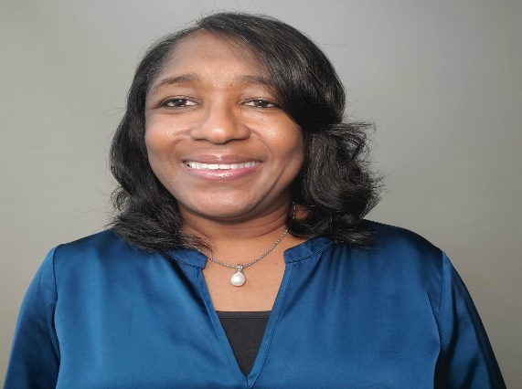

Dionne Swift
Principal Statistician
The Procter and Gamble Company
I am a Principal Statistician at Procter & Gamble in the Data and Modeling Sciences Department providing statistical capability leadership, technical and collaborative research skills with Biosciences and Life Sciences organizations to amplify and accelerate product and technology innovation. My current research focuses on high-dimensional data analysis, multi-omics integrative analysis, and Bayesian data analysis and causal inference with application in genomics proteomics, and microbiome research.

I live in Franklin, OH with my husband and two sons, but grew up in a small rural area outside of Georgetown, SC. Since middle school, I had always known that I would pursue a math or science related occupation. My interest in science and math were sparked by my late dad. He was an engineer technical at SC public utility provider who took me on tours of his labs and discussed his experimental results. Of course, I did not always understand his data and calculations, but I was amazed at how his work helped to provide reliable power and clean water to SC residents. In addition, math and science were my favorite classes. I was fortunate to have math and science teachers who looked like me in both middle and high school. They were relatable role models who encouraged my interest. They along with my parents were always supportive and encouraged my educational pursuits.

After high school, I enrolled in Oakwood University, an HBCU in Huntsville, AL, as a mathematics major and chemistry minor. My modern algebra professor, who was Chair of the Math Department, was the first person to discuss pursuing a doctoral degree. Until then, attending graduate school or pursuing a PhD was something I had never considered. I was fortunate to be in an environment where I had professors who actively encouraged me to consider graduate school and provided opportunities for undergraduate research. Initially, I considered applied mathematics for graduate studies since I wanted to solve real-life problems. However, after two summer college internships at Eli Lilly and Co, I decided to pursue graduate studies in statistics. The internships provided opportunities to combine my mathematical skills to solve real-world problems and introduced the value of statistics to various research disciplines. Mentors increased my awareness of various career opportunities for statisticians, and one mentor graciously arranged a college visit to his graduate alma mater.

Shortly after receiving my Ph.D. in mathematical statistics from The Ohio State University in 2000, I joined Procter and Gamble (P&G) as a Statistician. Over the years, I have partnered closely with engineers and scientists in numerous business and corporate groups, integrating learning throughout project planning, development of test designs, and modeling. For various brands such as Tide, Gain, and Olay, my technical and collaboration skills have enabled new product claims, the development of new business concepts, and the identification of lead technologies to drive concepts to success. I have received multiple business awards for Leveraging Mastery, Innovating for Growth, Championing Productivity, Leadership, Executional Excellence, and Teamwork Winning Together for delivering business and organizational projects.

Many individuals– family, friends, mentors, mentees, advocates, professors, and managers– have impacted my life, career, and professional development and contributed to my personal and professional successes. Because of the influence and impact of others, I desire to inspire and motivate others to achieve their educational and professional dreams. Thus, I am continually active in the initiatives of the American Statistical Association Committee on Minorities including serving as a mentor since 2012. I also serve as a mentor at P&G and help to deliver programs to support the African Ancestry (AA) community, recruit AAs from STEM disciplines, and drive the retention and advancement of AAs. The quote “some of us will make tiny ripples and others will send waves crashing, but each one will change the surface of the water forever” by Robin Dance summarizes my philosophy of the impact one can have in our communities and on the lives of others. My proudest moments are when individuals I mentor, coach, or support achieve their personal or professional goals.
© The Network of Minorities in Mathematical Sciences 20201

